REPUBLIQUE DU CAMEROUN

Paix-Travail-Patrie

****** MINISTERE DE

L’ENSEIGNEMENT SUPERIEUR

****** INSTITUT AFRICAIN

D’INFORMATIQUE (IAI)

REPUBLIC OF CAMEROON

***Course Instructor***

**Mr. FOMEKONG** Nze Stephane

**Academic Year:**

2024/2025

***Developed by***

**AFANYUY** Caleb & **OMBANG** Yvan Jorel

SE3A Students of AICS Cameroon

**A Tour Guide In The Center**

A MOBILE APPLICATION FOR

BP 13 719 Yaoundé (Cameroon) Tel. (237) 22 72 99 57/ (237) 22 72 99 58

Web site: [www.iaicameroun.com](http://www.iaicameroun.com) E-mail: contact@iaicameroun.com

Peace-Work-Fatherland

****** MINISTRY OF HIGHER

EDUCATION

****** AFRICAN INSTITUT OF

COMPUTER SCIENCES (AICs)

GENERAL INTRODUCTION 3

PRESENTATION OF THE PROJECT 4

CONTEXT 4

JUSTIFICATION 4

PROJECT TARGET 5

ANALYSIS METHODOLOGY 7

Introduction 7

Comparison of UML and Merise 7

DIAGRAMS 8

USE CASE DIAGRAM 8

TEXTUAL DESCRIPTION 11

COMMUNICATION DIAGRAM 13

SEQUENCE DIAGRAM 15

ACTIVITY DIAGRAM 17

STATE MACHINE DIAGRAM 19

CLASS DIAGRAM 20

PACKAGE DIAGRAM 22

COMPONENT DIAGRAM 23

DEPLOYMENT DIAGRAM 24

PROJECT ILLUSTRATIONS 25

CONCLUSION 26

# LIST OF FIGURES

Figure 1: formalism of the use case 9

Figure 2: general use case diagram 11

Figure 3: explore use case 11

Figure 4: formalism of communication diagram 14

Figure 5: explore communication diagram 15

Figure 6: authentication sequence diagram 16

Figure 7: explore sequence diagram 17

Figure 8: activity digram formalism 18

Figure 9: authentication activity diagram 18

Figure 10: explore activity diagram 19

Figure 11: formalism of state diagram 20

Figure 12: attraction site state diagram 20

Figure 13: class diagram formalism 21

Figure 14 System class diagram: 22

Figure 15: A package diagram formalism 23

Figure 16: system package diagram 23

Figure 17 component diagram formalism 24

Figure 18: system component diagram 24

Figure 19: deployment diagram format 25

Figure 20: System deployment diagram 25

# LIST OF TABLES

Table 1: components of communication diagram 15

Table 2: components of a class diagram 22

# GENERAL INTRODUCTION

Tourism plays a vital role in cultural preservation and economic growth, offering travelers a unique opportunity to explore new destinations. The **Tour Guide Mobile Application** is designed to enhance tourism in the **Center Region of Cameroon** by providing visitors with a digital companion that offers guided tours, real-time navigation, and historical insights into various sites of interest.

The Center Region, home to Cameroon’s capital **Yaoundé**, is rich in cultural heritage, historical landmarks, and natural attractions. However, many tourists struggle with accessing reliable information about these sites, leading to challenges in navigation, historical interpretation, and overall trip planning. This application addresses these issues by offering a seamless, interactive, and informative experience tailored to both local and international visitors.

This report details the development of the **Tour Guide Mobile Application**, outlining its objectives, features, system architecture, and potential impact on tourism in the region. By leveraging **modern technology, location-based services, and multimedia content**, the application aims to provide an engaging and convenient way for users to discover the hidden gems of the Center Region of Cameroon.

# PRESENTATION OF THE PROJECT

## CONTEXT

Tourism is a key driver of cultural exchange and economic development, particularly in regions with rich historical and natural heritage. The **Center Region of Cameroon,** home to the capital city **Yaoundé,** is a hub of cultural and historical significance, boasting landmarks such as the **National Museum, Mefou National Park, Ebogo Ecotourism Site, and the Cathedral of Our Lady of Victories**. Despite the region’s tourism potential, many visitors face difficulties in accessing structured information, reliable navigation, and historical insights about these sites.

With the increasing adoption of **smartphones and digital services,** mobile applications have become essential tools for enhancing the travel experience. A **Tour Guide Mobile Application** tailored to the Center Region of Cameroon can bridge the gap between tourists and local attractions by providing **real-time navigation, multimedia content, historical descriptions, and personalized tour recommendations.**

## JUSTIFICATION

The development of this application is justified by several factors:

1. **Lack of Centralized Information** – Many tourists rely on scattered and outdated information from websites, guidebooks, or word-of-mouth recommendations, making trip planning cumbersome. The app provides a **centralized platform** for verified and up-to-date details on touristic sites.
2. **Enhancing Tourist Experience** – Traditional tours are often limited by guide availability and language barriers. A mobile tour guide offers **self-paced, multilingual support** with interactive features, improving accessibility for a diverse audience.
3. **Boosting Local Tourism** – The application can promote lesser-known attractions, helping to **increase visitor numbers and generate economic benefits** for local communities, artisans, and service providers.
4. **Integration of Smart Technologies** – By leveraging **GPS navigation and multimedia content**, the app offers an **immersive and engaging experience**, making tours more informative and interactive.
5. **Sustainability and Cost Efficiency** – Unlike traditional paper-based guides and in-person tour services, a mobile application offers a **cost-effective, environmentally friendly**, and **easily updatable** alternative for delivering tourism-related information.
6. **Safety and Convenience** – With features such as **offline maps, emergency contact information, and real-time site availability**, the app ensures that tourists can explore the region **safely and efficiently**.

By addressing these challenges and opportunities, the **Tour Guide Mobile Application** is expected to transform how tourists explore the Center Region of Cameroon, offering a **modern, digital-first approach** to cultural discovery and travel assistance.

## PROJECT TARGET

The **Tour Guide Mobile Application** is designed to serve a diverse range of users with a common interest in exploring the **Center Region of Cameroon**. The primary targets of this project include:

### ****Tourists (Local and International)****

The main users of the application are **tourists visiting the Center Region**. These include:

* **International visitors** who may not be familiar with the area and require a structured, self-guided tour experience.
* **Domestic tourists** from other regions of Cameroon looking to explore the historical and cultural sites of the Center Region.

The app provides **GPS navigation, historical insights, and real-time site availability** to enhance their experience.

### ****Local Tour Operators and Guides****

The platform can serve as a **digital assistant** for **local tour guides and tourism agencies**, enabling them to:

* Offer additional information to clients through **multimedia content**.
* Provide **structured itineraries** and **personalized recommendations** to enhance customer satisfaction.
* Advertise **guided tours and travel packages** to attract more visitors.

### ****Government and Tourism Authorities****

The application can assist **government agencies such as the Ministry of Tourism and Leisure** by:

* Promoting **cultural heritage and eco-tourism** in the Center Region.
* Providing **data analytics** on visitor trends and preferences for better tourism planning.
* Encouraging **sustainable tourism** by directing visitors to approved and environmentally friendly sites.

### ****Local Businesses and Artisans****

By increasing foot traffic to various attractions, the app indirectly benefits **local businesses, restaurants, hotels, and artisans** who provide services to tourists. These stakeholders can:

* Advertise their services within the app.
* Attract more customers by offering **location-based recommendations** and **exclusive deals**.

### ****Students and Researchers****

Educational institutions and researchers studying **history, culture, and tourism development** can use the app as a **resourceful tool** to access information on historical landmarks and local traditions.

* **Adventure and Nature Enthusiasts**

For those interested in **eco-tourism, hiking, and outdoor activities**, the app offers information on **natural reserves, parks, and adventure trails**, ensuring a safe and well-informed experience.

# ANALYSIS METHODOLOGY

## Introduction

The project analysis for the Tour Guide Application involves employing the Unified Modeling Language (UML) as the primary modeling tool. UML is a standardized visual language that enables us to effectively capture and analyze the various aspects of the project, from requirements to design and implementation. By utilizing UML, we can create clear and concise visual representations of the system, facilitating communication and understanding among stakeholders and development teams. This introduction sets the stage for how UML will be used throughout the project analysis.

## Comparison of UML and Merise

When it comes to modeling methodologies, UML offers distinct advantages over the Merise methodology. While Merise focuses primarily on data modeling, UML provides a more comprehensive approach, encompassing the modeling of system behavior, structure, and interactions. UML allows us to create a broader range of diagrams, such as use case diagrams, class diagrams, and sequence diagrams, enabling a more holistic understanding of the system.

Unlike Merise, UML is not limited to database design but offers a versatile modeling approach that can be adapted and extended as the project evolves. UML's flexibility allows for easy modification and scaling, accommodating changing requirements and ensuring the system's future growth. This adaptability is crucial for the digitalized mortuary application, as it needs to cater to the evolving needs of mortuaries and the families they serve.

Overall, UML's comprehensive nature and flexibility make it a superior choice for our project analysis. It provides us with the means to capture a complete system representation, communicate effectively, and adapt to future changes. By utilizing UML, we can ensure a robust and well-designed digitalized mortuary application that meets the needs of both mortuary staff and grieving families.

# DIAGRAMS

## USE CASE DIAGRAM

### Definition

Use case diagram shows the functionalities of a system, their interdependencies and how they relate with actors of the system. A use case is a specification of behaviour. The main objectives of the use case diagram are:

❖ Provide a high-level view of the system.

❖ Identify the functions of the system.

Use case diagrams are completed with a textual description of each use case that is intended to define the use case in greater details

### Formalism

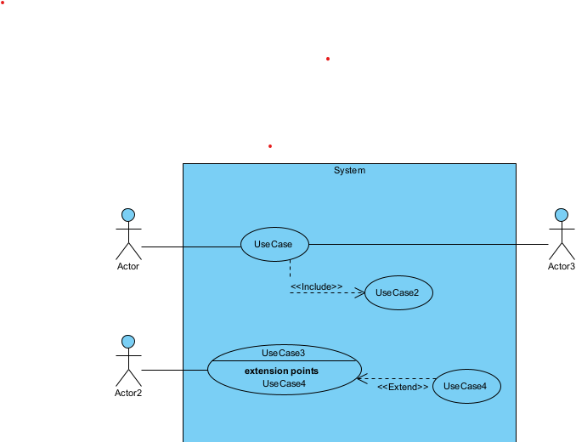

Figure 1: formalism of the use case

### Components of a use case diagram

Table 1: components of a use case

|  |  |  |
| --- | --- | --- |
| **Elements** | **Diagrammatic Representation** | **Description** |
| **Actor** |  | Represents an entity that directly interacts with the system. The actor is what performs the different possible actions of the system |
| **Use case** |  | A use case represents a functionality of the system. It is an action that can be performed by an actor. |
| **Association** |  | it indicates that an actor takes part in a use case. |
| **Include** |  | An inclusion denotes that an included action must be performed before the including action can be performed. |
| **Extend** |  | An extension denotes that an extending action may be performed while an extended action is being performed. |
| **Generalization** |  | This shows that an actor or a use case is a kind of another abstract or concrete actors can be defined and later specialized using generalization relationship. |
| **System** |  | It is a container of use cases which interact with external actors |

### Actors of the System

Table 2: actors of the system

|  |  |
| --- | --- |
| System Actors | |
| Admin | The user that is in charge of controlling the entire system |
| Tourist | A regular user that has downloaded and installed the app |
| Geolocation API | The external system in charge of maps |

### General Use case

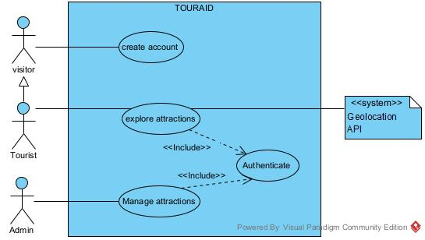

Figure 2: general use case diagram

### Explore Use case

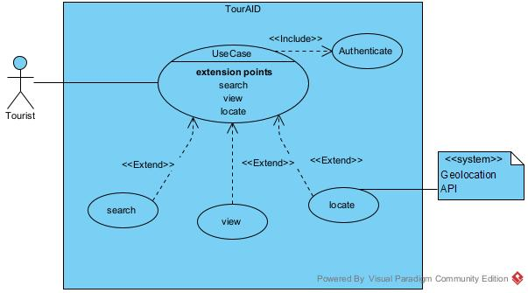

Figure 3: explore use case

## TEXTUAL DESCRIPTION

### Authentication

Table 3: Authentication textual description

|  |  |
| --- | --- |
| **Title** | Authenticate |
| **Summary** | The user needs to authenticate |
| **Actors** | Tourist, admin |
| **Date** | February 11, 2025 |
| **Stakeholder** | TourAid Directors |
| **Version** | 1.0 |
| **Precondition (s)** | 1. The app is launched. 2. The actor has an account on the platform. |
| **Triggers** | The user clicks on login button |
| **Nominal Scenario** | 1. The system displays the login form. 2. The actor fills and submits the form. 3. The system verifies conformity of the form fields 4. The system sends the data to the dbms. 5. The dbms returns result of the query. 6. The system displays a success message to the actor. |
| **Alternative Scenarios** | 1. At step 4 of the nominal scenario, the user enters mismatched or missing information. 2. The system displays an error message then returns to step 2 of the nominal scenario. |
| **Postcondition of success** | The user has access to the homepage of the application |
| **Postcondition of failure** | The user does not have access to the platform |
| **Non-functional requirement** | Entering the password must not be visible on the screen |

### Explore Attractions Use case

Table 4: Explore attractions textual description

|  |  |
| --- | --- |
| **Title** | Explore |
| **Summary** | The user needs to see the registered attraction sites |
| **Actors** | Tourist |
| **Date** | February 11, 2025 |
| **Stakeholder** | TourAid Directors |
| **Version** | 1.0 |
| **Precondition (s)** | 1. The app is launched. 2. The user has authenticated. |
| **Triggers** | The user clicks on the login button |
| **Nominal Scenario** | 1. The system displays the home page 2. The actor enters a site in the search bar. 3. The system sends the fetch query to the DBMS 4. The DBMS executes the query and returns the result 5. The system displays sites based on the actors search text 6. The actor chooses a site 7. The system displays the site information 8. The actor clicks on the locate button 9. The system sends the coordinates to the Geolocation API which sends a response 10. The system displays the location on the Map |
| **Alternative Scenarios** | 1. At step 3 of the nominal scenario, the user enters a site that is not found 2. The system displays a blank page |
| **Postcondition of success** | The user is able to locate an attractions |
| **Postcondition of failure** | The actor does not locate the attraction site |
| **Non-functional requirement** | * Entering the password must not be visible on the screen * Interaction with the mapping API should be almost instant |

## COMMUNICATION DIAGRAM

### Definition

Communication Diagrams model the interactions between objects in a sequence. They describe both the static structure and the dynamic behavior of a system. It is a simplified version of a Collaboration Diagram introduced in UML 2.0. A communication diagram is more focused on showing the collaboration of objects rather than the time sequence.

### Formalism

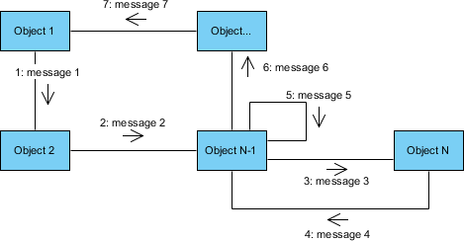

Figure 4: formalism of communication diagram

1. **Components of a communication diagram**

Table 1: components of communication diagram

|  |  |  |
| --- | --- | --- |
| Elements | Diagrammatic Representation | Description |
| Object |  | An object represents an individual participant in the interaction conversation |
| Actor |  | An actor is a special object in charge of initiating conversions |
| message |  | Defines a particular communication between objects |
| link |  | Represents the relationship that exists between lifelines |

### Explore Communication Diagram

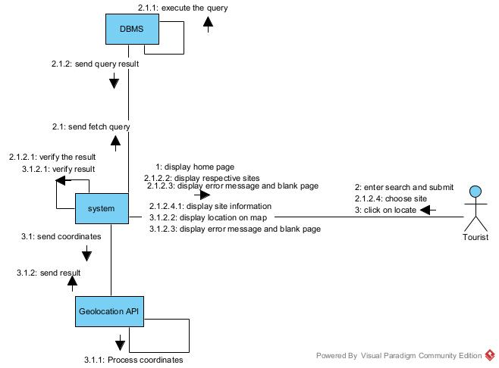

Figure 5: explore communication diagram

## SEQUENCE DIAGRAM

### Definition

A Sequence diagram describes interactions among classes in terms of an exchange of messages over time. They are also called event diagrams. A Sequence diagram is a good way to visualize and validate various runtime scenarios. These can help to predict how a system will behave and to discover responsibilities a class may need to have in the process of modelling a new system.

### Formalism

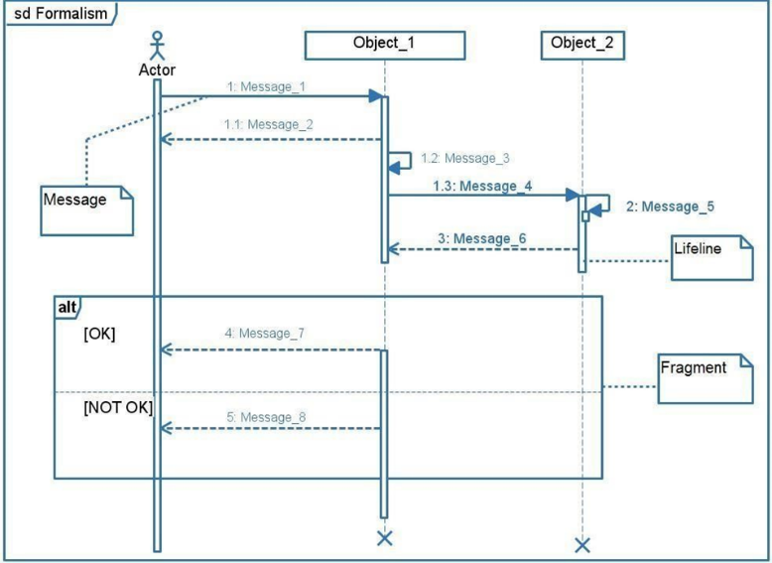

### Authentication Appointment diagram

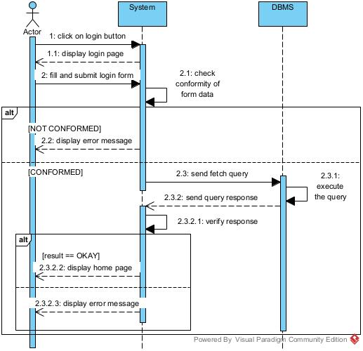

Figure 6: authentication sequence diagram

### Explore Sequence diagram

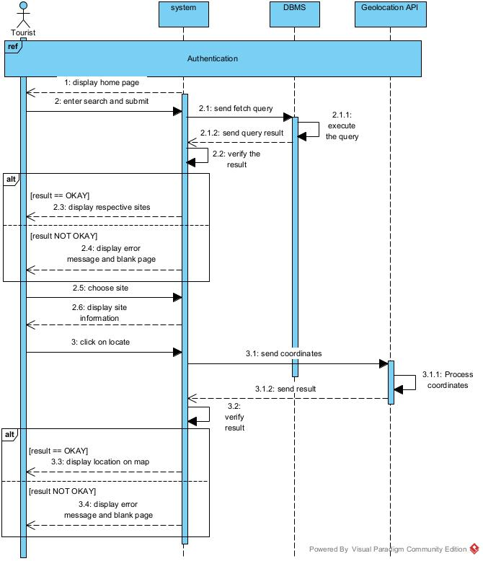

Figure 7: explore sequence diagram

## ACTIVITY DIAGRAM

### Definition

An activity diagram is a graphical representation of workflows that show the steps needed in the realization of a process; showing the details from a start point to an end point through all decisions and actions that can possible be performed. Activity diagrams are intended to model both the computational and organizational process. They flow can be sequential, branched or concurrent. Below is an activity diagram formalism.

### Formalism

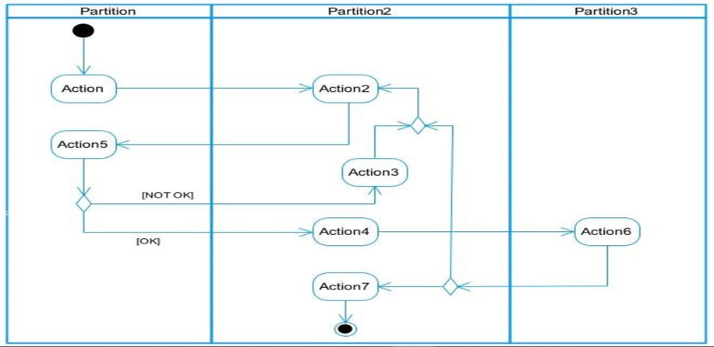

Figure 8: activity digram formalism

### Authentication Activity

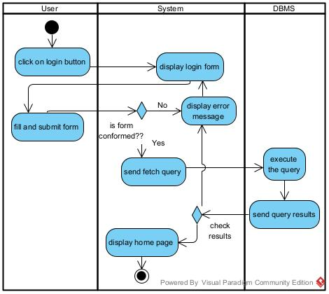

Figure 9: authentication activity diagram

### Explore activity diagram

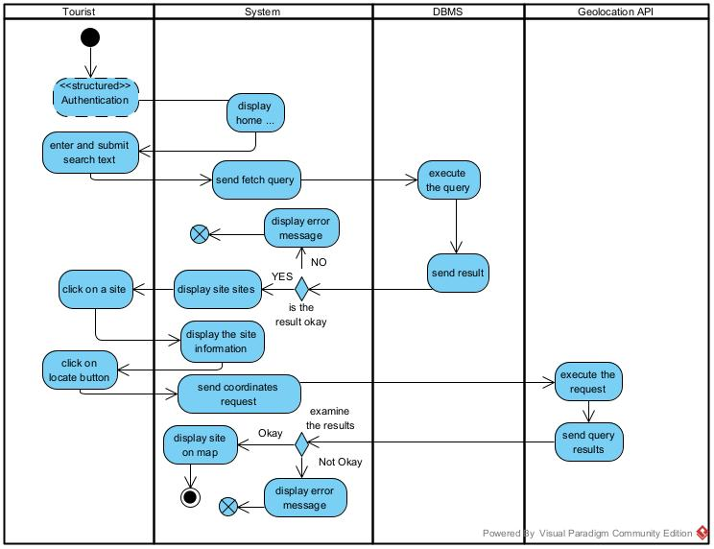

Figure 10: explore activity diagram

## STATE MACHINE DIAGRAM

### Definition

A state machine diagram describes the behavior of a single object in response to a series of events in a system. Also known as the state machine diagram, it models the dynamic flow of control from the state of a particular object within a system.

### Formalism

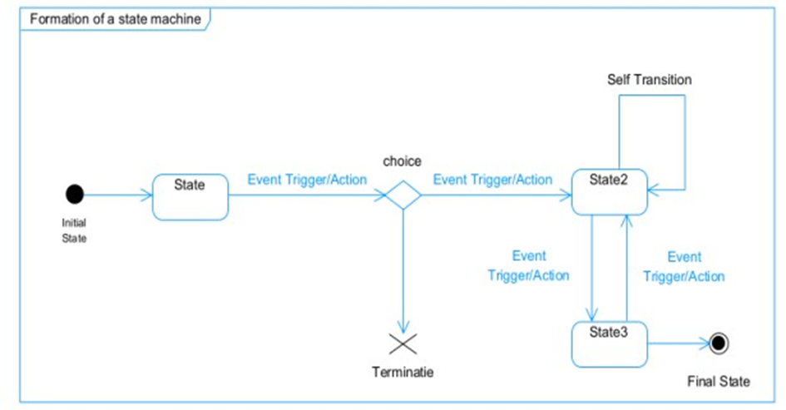

Figure 11: formalism of state diagram

### Attraction State Diagram

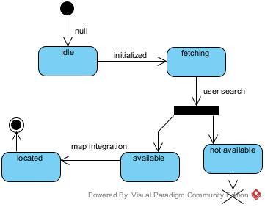

Figure 12: attraction site state diagram

## CLASS DIAGRAM

### Definition

A class diagram is a static diagram. It represents the static view of an application. class diagram is not only used for visualizing, describing and documenting different aspect of the system but also for constructing executable code of the software application. Class diagram describes the attribute and operation of a class and constraints imposed on the system. Its purpose is to model the static view of an application.

### Formalism

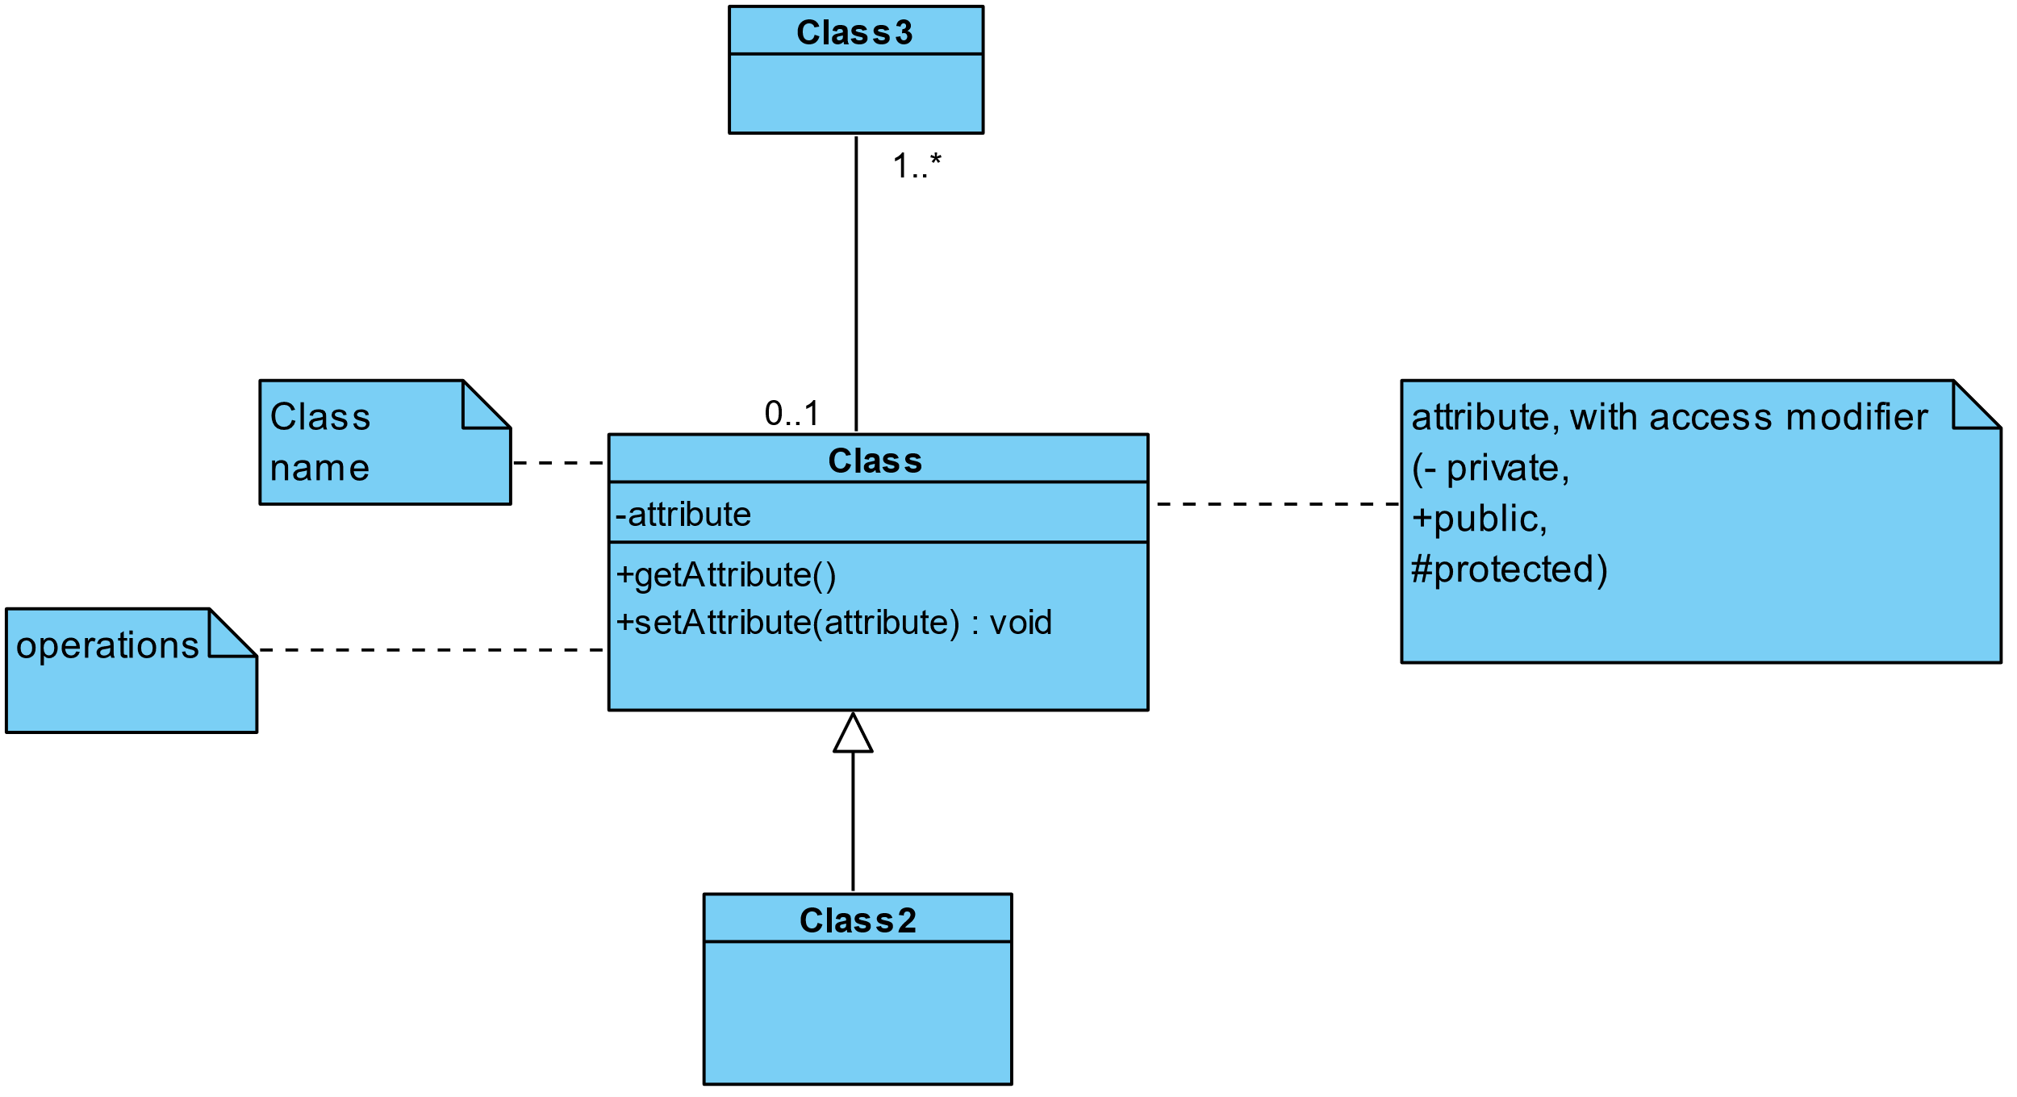

Figure 13: class diagram formalism

### Components of A class Diagram

Table 2: components of a class diagram

|  |  |  |
| --- | --- | --- |
| Element | Diagrammatic Representation | Description |
| Class |  | A class is an element that defines the structure and behaviours that an object can possess. |
| Aggregation |  | If the parent of the aggregate is deleted, usually the children are not deleted. |
| Composition |  | If a parent of a composite is deleted, usually, all its parts are deleted with it. |
| Dependency |  | It exists between two classes, where a change in one influence the other. |
| Generalization |  | It’s a relationship between a whole class (called superclass) and a more specific class (called subclass) |
| Association |  | It is a general type of relationship between elements, it may include  cardinality, roles etc. |

### System Class Diagram

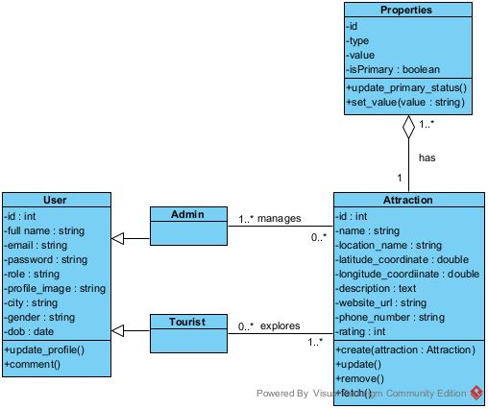

Figure 14 System class diagram:

### Business Rules

R1: An admin user manages none or many attraction sites and an attraction site can be managed by many system administrators

R2: A tourist can explore zero or many attraction sites and an attraction site can explored by none or many tourists

R3: An attraction site must have at least one property, beit image, video or audio content and a property belongs to only one attraction site.

## PACKAGE DIAGRAM

### Definition

This is a structural diagram used to show the organization and arrangement of various model elements in the form of packages. A package diagram is the grouping of related uml elements such as classes, diagrams or even other packages

### Formalism

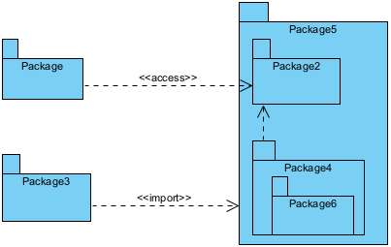

Figure 15: A package diagram formalism

### System package diagram

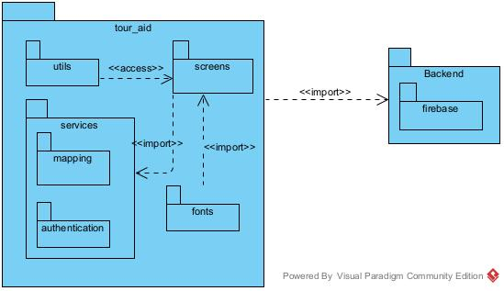

Figure 16: system package diagram

## COMPONENT DIAGRAM

### Definition

Component diagrams are used to model the physical aspect of a system. Now the question is what are this physical aspect? They are elements such as Executables, libraries, files, document etc. which resides in a node. The component diagram does not describe the functionality of the system, but it describes the components used to make those functionalities.

### Formalism

Figure 17 component diagram formalism

### System Component Diagram

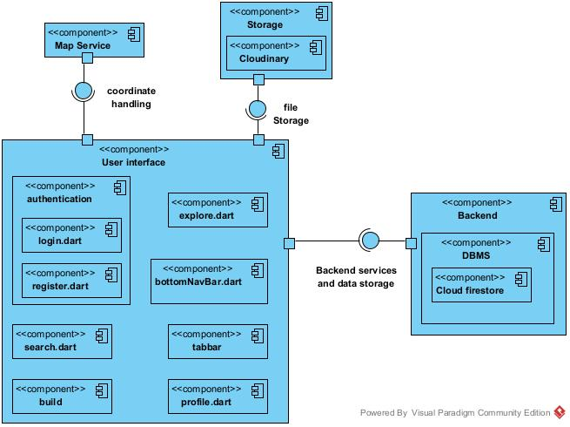

Figure 18: system component diagram

## DEPLOYMENT DIAGRAM

### Definition

Deployment diagram is a structural diagram used to visualize the topology of the physical components of a system, where the software is deployed. They consist of nodes and their relationship. It is related to the component diagram because the components are deployed using the deployment diagram. A deployment diagram consists of nodes.

Nodes are nothing but physical hardware used to deploy the application.

### Formalism

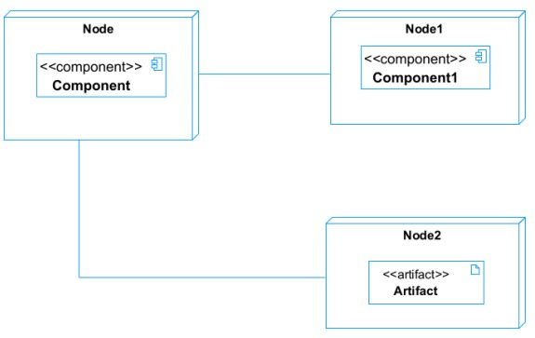

Figure 19: deployment diagram format

### System Deployment Diagram

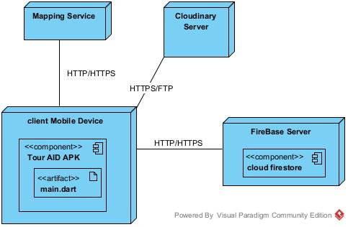

Figure 20: System deployment diagram

# PROJECT ILLUSTRATIONS

# CONCLUSION

The **Tour Guide Mobile Application** is a modern solution aimed at transforming the tourism experience in the **Center Region of Cameroon**. By leveraging **digital technology, real-time navigation, multimedia content, and site availability tracking,** the application provides a **seamless, informative, and interactive** way for tourists to explore cultural and historical attractions.

This project not only enhances the **accessibility and convenience** of tourism but also supports **local businesses, tour operators, and government agencies** in promoting sustainable and well-organized travel experiences.

Beyond its immediate benefits to tourists, the application contributes to **economic growth, cultural preservation, and tourism development** in the region. With the increasing adoption of smartphones and mobile-based travel solutions, this initiative represents a **significant step toward digitalizing tourism services in Cameroon.**